**Three Interacting Chemicals in Porous Media Verification**

This verification example demonstrates the multi-SV functionality of GEM involving the concentrations of three interacting chemicals in a porous medium. The example utilized the van Genuchten (1985) analytical solution as implemented in a web-based tool by faculty and students at the University of Illinois (<http://hydrolab.illinois.edu/gw_applets/> ). The example considers advection and dispersion/diffusion, linear equilibrium sorption, and sequential decay of solutes under constant velocity conditions, a specified constant concentration at the inflow boundary, and initial concentrations of 0 within a semi-infinite domain. Chemical 1, which has a surface boundary condition of 1 g/m3, decays to Chemical 2, which then decays to Chemical 3. Therefore, as Chemical 1 concentrations decrease with depth, concentrations of Chemicals 2 and 3 increase, albeit with a lag.

The first two columns of Table 1 give the parameters needed for the analytical solution. The environmental parameters are the pore velocity and diffusion/dispersion coefficient. The chemical-specific parameters needed are the inflow concentrations, the daughter product decay rates, the additional internal decay rate for chemical 3, and the retardation coefficients. The daughter product decay rates convert chemical 1 into chemical 2 and chemical 2 into chemical 3. The chemical 3 internal decay rate decays chemical 3 without conversion to another chemical. The units on the analytical parameters are arbitrary, but must be dimensionally consistent (Valocchi, 2017).

We set up a GEM model with 202 1-D compartments as shown in Figure 1. Compartments 1 and 202 are upper and lower boundary conditions, respectively. Compartments 2 – 201 are the modeled compartments (N=200). Each compartment had a surface area of 1 m2 and a depth of 1m, for a total of 200 m depth. Fixed, constant, upper boundary conditions were specified in accordance with the inflow concentrations for each chemical given in Table 5.1. Lower boundary conditions were fixed, constant values of 0 g/m3.

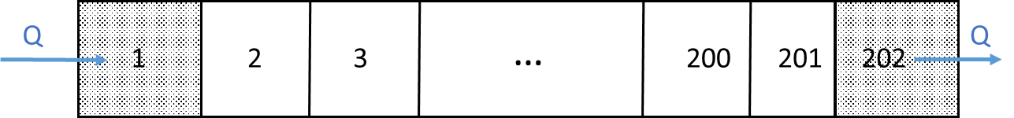

Figure 1. Compartment Structure for Van Genuchten Verification Example

The GEM parameters are also given in Table 1. We elected to interpret the analytical solution parameters in default GEM units (m,g,day) and the corresponding values are given in the table. The GEM’s flow rate, water content, bulk density, and Kd parameters were “free” in the sense that they are not inputs to the analytical solution. However, in combination, they must return the 1.0 m/day pore velocity as well as the retardation coefficient inputs to the analytical solution. Accordingly, we arbitrarily assigned the water content and bulk density values, and calculated the flow rate to yield 1.0 m/day pore velocity. Similarly, Kd was calculated to yield the examples’ retardation coefficients.

Table 1. Input Parameters for Van Genuchten Verification Example

|  |  |  |  |
| --- | --- | --- | --- |
| **Applet Parameters** | **Value** | **GEM Parameters** | **Value** |
| Pore Velocity | 1 m/day |  |  |
| Dispersion Coefficient | 0.18 m2/day | Dispersion Coefficient | 0.18 m2/day |
|  |  | Advective Flow (Q) | 0.5 m3/day |
|  |  | Bulk Density (Bd) | 1.0E06 g/m3 |
|  |  | Water Content (θ) | 0.5 |
| **Chemical 1 Parameters** | | | |
| Inflow Concentration | 1.0 g/m3 | Inflow Concentration | 1.0 g/m3 |
| Daughter Product Decay Rate[1] | 0.1/day | Daughter Product Decay Rate | 0.1/day |
| Retardation Coefficient (1+Bd*Kd/θ) | 2 | Sorption Partition Coefficient (Kd) | 0.5E-06 m3/g |
| **Chemical 2 Parameters** | | | |
| Inflow Concentration | 0 g/m3 | Inflow Concentration | 0 g/m3 |
| Daughter Product Decay Rate | 0.05/day | Daughter Product Decay Rate | 0.05/day |
| Retardation coefficient (1+Bd*Kd/θ) | 1.5 | Sorption Partition Coefficient (Kd) | 2.5E-07 m3/g |
| **Chemical 3 Parameters** | | | |
| Inflow Concentration | 0 g/m3 | Inflow Concentration | 0 g/m3 |
| Decay Rate | 0.01/day | Decay Rate | 0.01/day |
| Retardation coefficient (1+Bd*Kd/θ) | 1.0 | Sorption Partition Coefficient (Kd) | 0.0 m3/g |

We ran the GEM for this example using the BTBS option for 200 days at a 10-day time step. The vertical profile at 200 days for each chemical is shown in Figure 2 along with the analytical model results. Despite our using a solution option (BTBS) that involves both temporal and spatial numerical dispersion, and a relatively large time step, there is generally excellent agreement between the two, with the exception of chemical 3 below 100 m. For chemical 3 below 100 m, we are unsure why there is some, albeit minor, deviation. We tried several lower boundary conditions including a fixed boundary of 0 g/m3, the exact analytical solution (0.01 g/m3), and a linear gradient-type boundary condition. GEM results were essentially the same for all of these tests suggesting that the lower boundary condition is not driving the solution. The root mean square error (RMSE) between simulated and analytical results is 0.01g/m3.

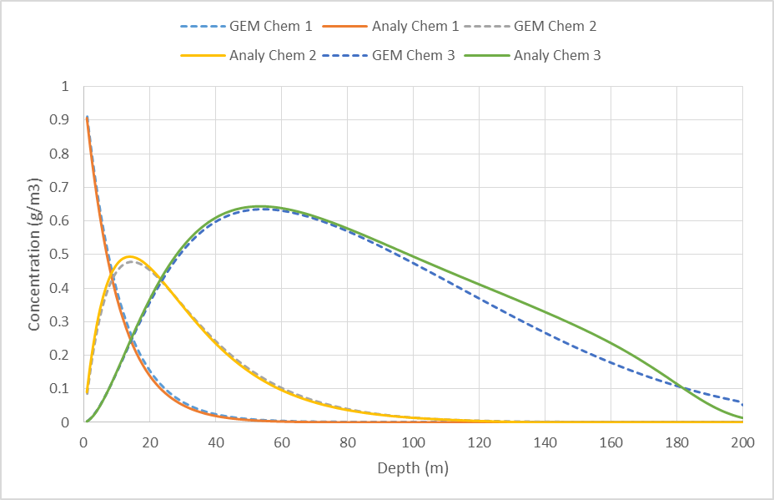

**Figure 2. GEM versus Analytical Solution for Van Genuchten Example**

**References**

Vallochi, A., 2017, University of Illinois Hydrolab, personal communication.

Van Genuchten, M.Th. 1985. *Convective-dispersive transport of solutes involved in sequential first-order decay reactions.* Computers & Geosciences, vol. 11, issue 2, pp. 129-147

1. The GEM accommodates two types of source/sink terms for linear problems. First-order reaction rate constants (/day) for chemical reactions affecting either a single or multiple chemicals (such as our current example) are entered into the “VolumeSrcSnks.csv” file. Analogously, transfer velocities (m/day) for cross-compartment mass transfers across an intercompartmental area (e.g., volatilization or settling) are entered into the “AreaSrcSnks.csv” file. Each rate constant or velocity is entered into a separate record giving the relevant SV(s) and compartment number(s). If a process is a sink for one compartment or chemical and a source for another, e.g. settling from compartment i to j or chemical reaction between chemicals i and j, two records are required, one for the sink term and another for the source. For example, for the 3-chemical interactions discussed here, if the 3 SVs are denoted as C1, C2, and C3, then the generalized mass balance equation (4) for compartment “i” would, for C1, have a sink term of - 0.1ViC1i and “-0.1” would be entered into the SV 1 record for compartment “i” of VolumeSrcSnks.csv. C2 would have a corresponding source term of + 0.1ViC1i and a sink term of - 0.05ViC2i in equation (4), and one record for SV 2 would have “0.1” while a separate record for SV 2 would have “-0.05”. C3 would have a corresponding source term of + 0.05ViC2i and a sink term of - 0.01ViC3i and also involve two records for SV 3. User inputs to AreaSrcSnks.csv follow a similar protocol.